
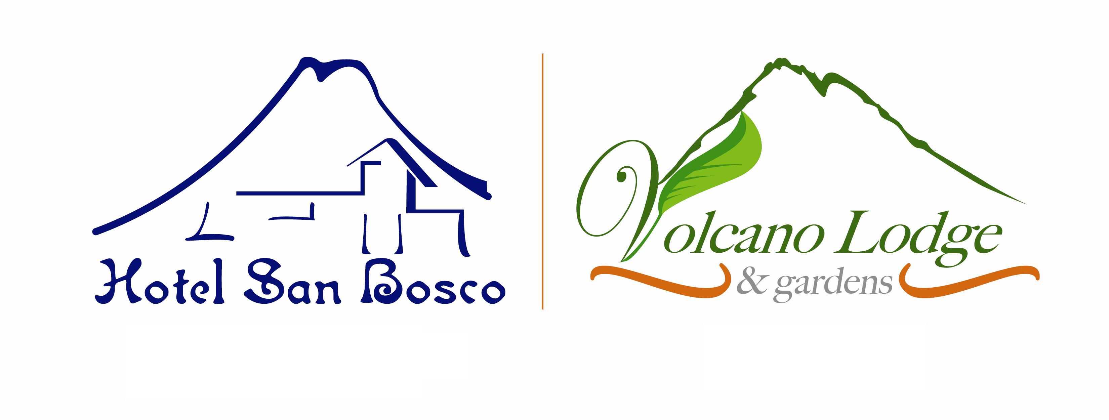

CARTÓN

TENDEDERO

VIDRIO
LAVANDERIA

DESECHOS

BODEGA DE
MANTENIMIENTO

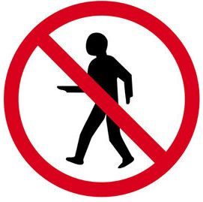
AUTHORIZED PERSONNEL ONLY

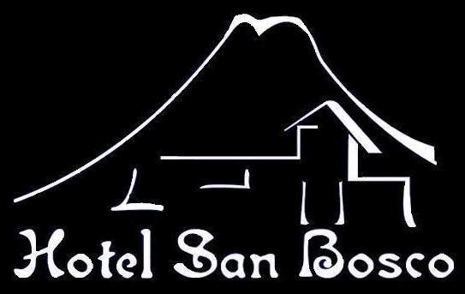


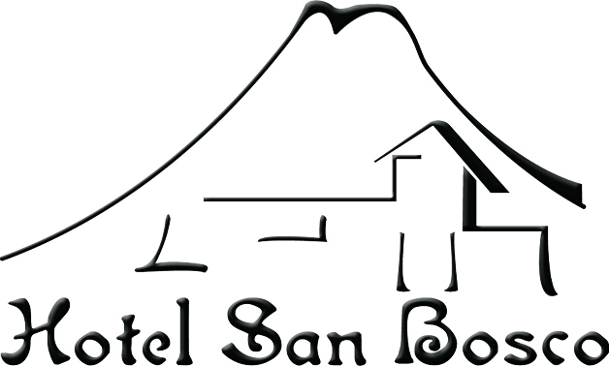
AUTHORIZED PERSONNEL
ONLY

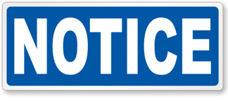
AUTHORIZED PERSONNEL ONLY

AltGr + Q = @

Alt + 64 = @
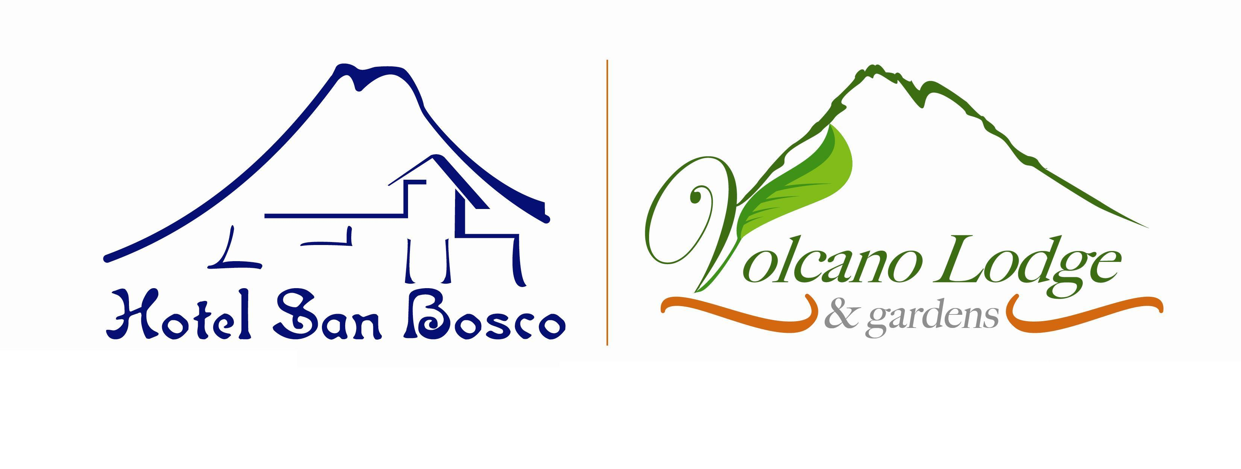


COFFEE

CAFÉ


HOT WATER

AGUA CALIENTE

PLEASE LEAVE THE COFFEE CUPS IN THIS AREA.
THANK YOU!


POR FAVOR DEJAR LAS TASAS EN EL AREA DEL CAFÉ
GRACIAS!

