

**TOURS INFORMATION**



**ADVENTURE ACTIVITIES**

**Mambo Combo**

Make the most of your limited vacation time!! Combine the exciting Adventures of Canyoneering and Rafting on the Beautiful Balsa River for a Full Day of Pure adrenaline. This unique tour includes a delicious typicallunch, snack, transportation and guide.

Departure Time: 7:00 am - Duration 8 Hrs

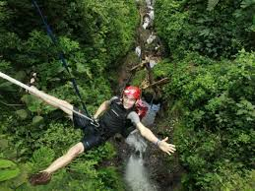

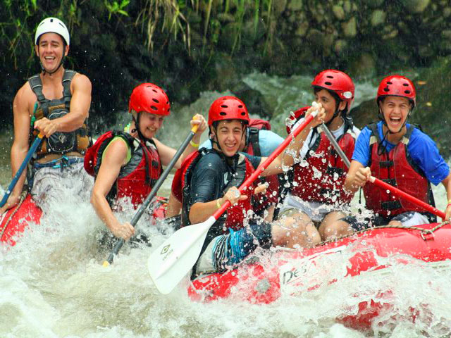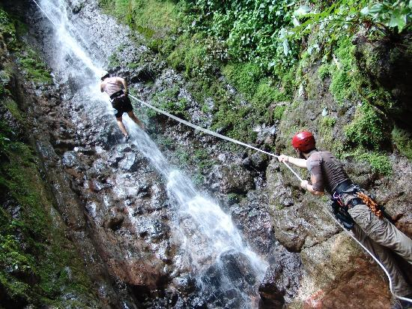

**Rafting Class II-III Balsa River**

Half day rafting class II-III closer to the Arenal Volcano!! Challenge yourself as you paddle through fun and safe rolling rapids. Hopefully you´ll get to see lots of wildlife like monkeys, sloths and tropical birds. This tour includes transportation, snack, typical lunch and guide.

Departure Time: 10:30 am - Duration 5 Hrs

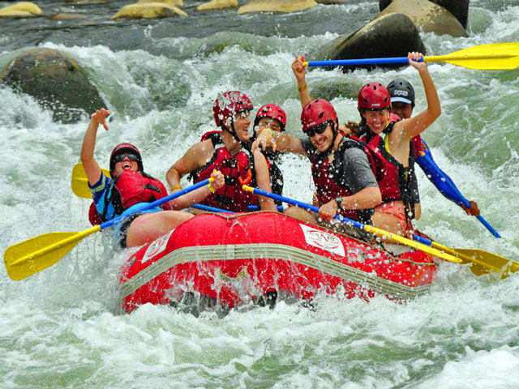

**Rafting Class III-IV**

This tour offers some of Costa Rica’s best white water with big waves, technical rapids and continuous whitewater. Could be Toro or Sarapiqui River depending the water level. This tour includes transportation, snack, typical lunch and guide.

Departure Time: 8:00 am - Duration 8 Hrs

**Canyoneering**

Take a walk combined with down-climb falls in an isolated jungle canyon in Arenal. This adventure is perfect for those looking to experience the thrill of descending breath taking waterfalls in a deep, jungle canyon while taking in the beauty of the rainforest! This tour includes transportation, typical lunch and guide.

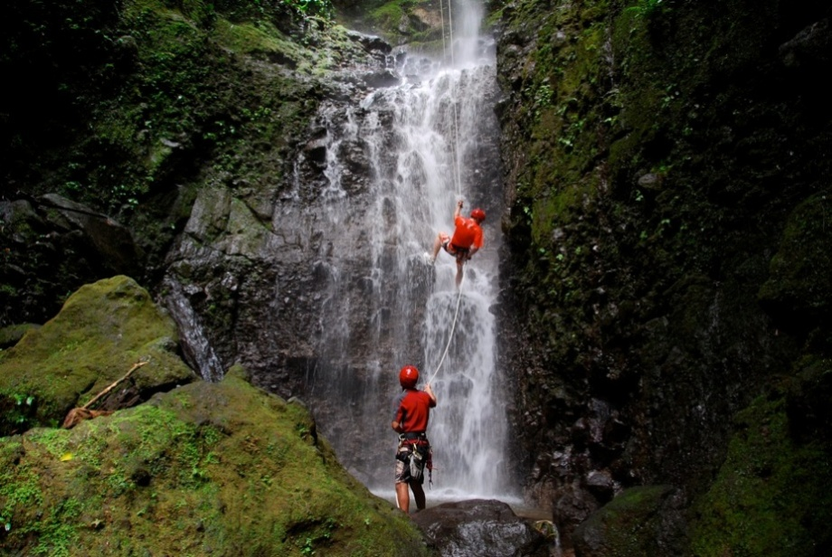Departure Times: 7:10 am, 9:40 am & 12:40 pm - Duration 4 Hrs

**Arenal Vista Canopy Tour**

A healthy release of adrenaline and an incredible immersion in nature with moving panoramic views. It will offer you the opportunity to observe wildlife in its natural habitat.10 cable from 80 to 750 meters length. This tour includes transportation and guide.

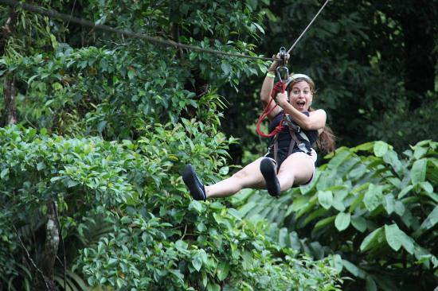Departure Times: 7:45 am, 10:15 am, 12:45 pm & 2:45 pm - Duration 2.5 Hrs

**Sky Tram & Sky Trek**

For maximum adrenaline rush. Ride the cable car up the heights and enjoy the zip lines with fantastic views of the Arenal Volcano and Lake. The tour includes 8 cross-sectional cables that together have a total length of 1.7 miles with distances from 100 to 2460 feet, and with a maximum height of 660 feet.

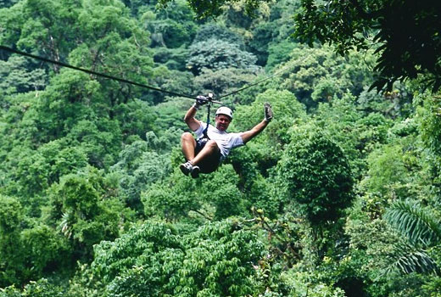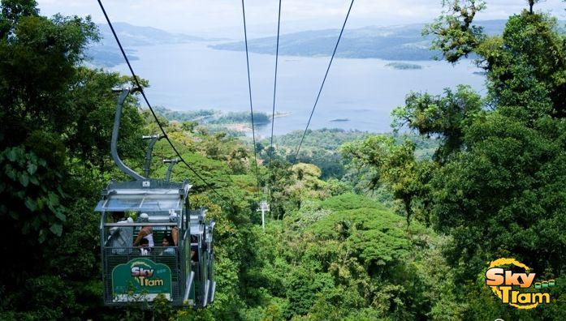Departure Times: 8:20 am, 9:50 am, 10:50 am, 1:20 pm, 2:20 pm & 3:15 pm - Duration 3.5

**Venado Caves**

Trek through underground waterfalls, prehistoric fossils and exotic cave formations. There are not lights or walkways, so you will feel as if you are the first person to discover them. There is no turning back now. It´s a little difficult to walk up the river, but that´s just part of the adventure. Includes transportation, guide and beverage.

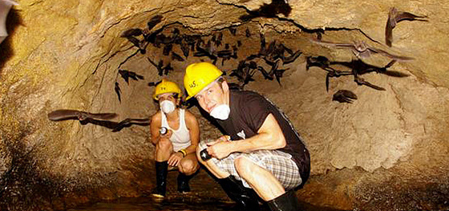 Departure Times: 7:00 am & 1:05 pm - Duration 4 Hrs

**ATV´s around the Volcano**

Experience the challenge of driving an ATV on the slopes of the volcano on trails through the forest. Includes transportation, guide and beverage.

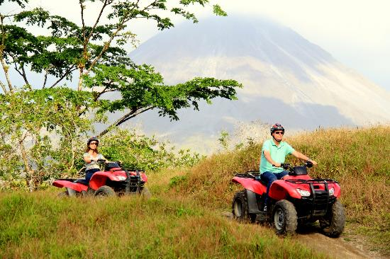Departure times: 7:50 am, 11:20 am & 2:50 pm - Duration 3 Hrs

**ATV´s to a Private Farm**

Adventure route to a private farm and visit to the Arenal River by ATV. Includes transportation, guide and lunch.

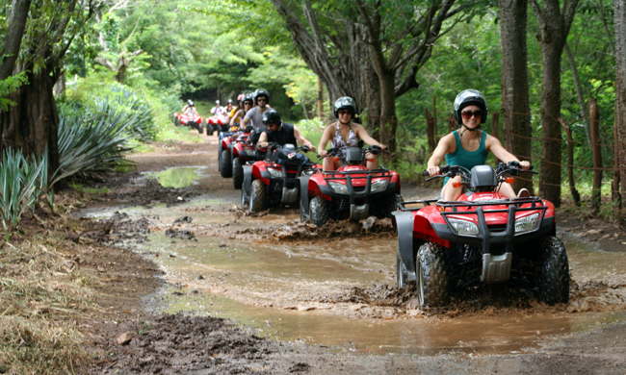Departure times: 7:15 am, 10:45 am & 2:15 pm - Duration 3 Hrs

**Horseback to La Fortuna Waterfall**

This is a great combination of horseback riding and Hiking to La Fortuna Waterfall. The ride is through green lands surrounded by tropical forest, during the way you will appreciate beautiful rivers, the company of a lot of birds. Include transportation, guide and entrance ticket.

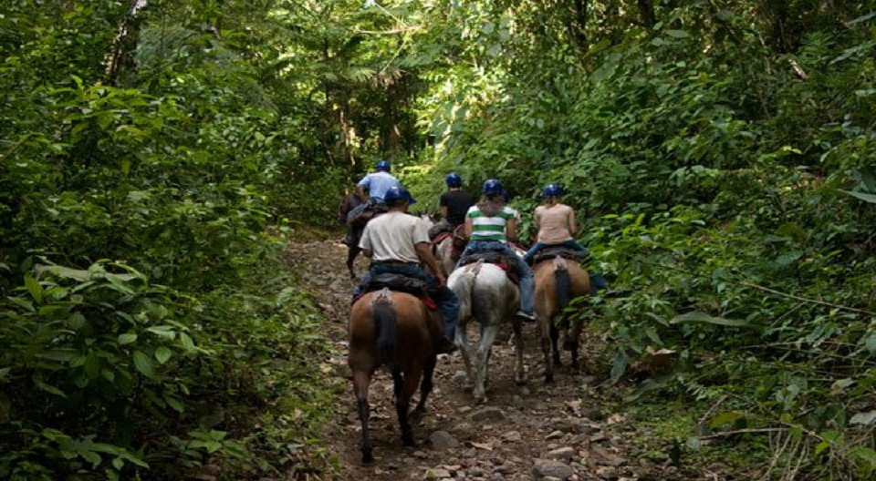Departure Times: 8:20 am & 1:10 pm - Duration 3.5 Hrs

**Horseback around the Arenal Volcano**

For Horse-Lovers and those who wish enjoy the most fascinating sceneries in the Arenal Conservation Area. This is your chance to see one of the most spectacular views of the Arenal Volcano. Include transportation, guide and entrance ticket.

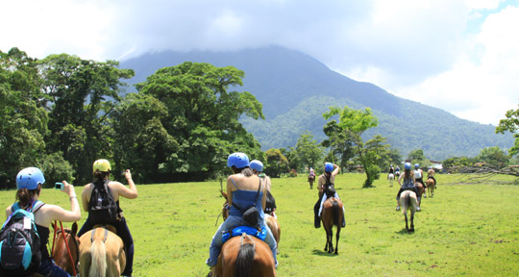Departure Times: 7:45 am, 11:15 am & 2:45 pm - Duration 3 Hrs

**Mountain Bike Ride**

Take a moderate level guided bike ride near to the base of Arenal Volcano and Lake. We´ll be biking on a quiet lane surrounded by dense forest and perfect views of the Arenal Volcano. Include equipment, transportation, snack and guide.

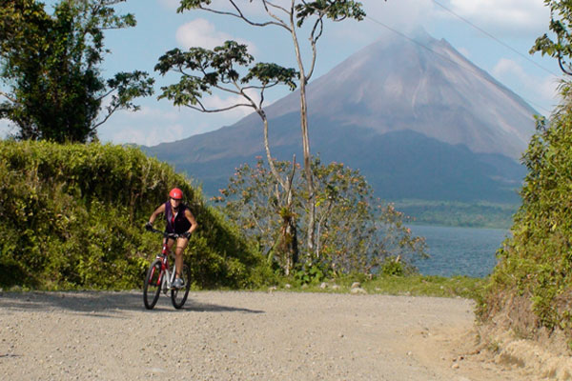Departure Times: 8:05 am & 1:45 pm - Duration 4 Hr

**Stand Up paddling Arenal Lake**

Stand up on a large, wide, super buoyant board similar to a surfboard and use a long paddle to move yourself along. You'll feel like you're walking in water! Include transportation, guide and snacks.

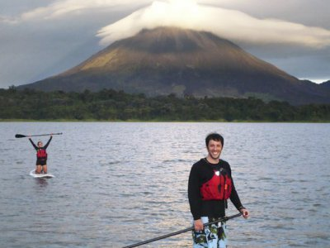Departure times: 8:05 am & 1:40 pm - Duration 4 Hrs



**NATURE LOVERS**

**Volcano Hike**

Hike along the trails of the National Park, we will enter into the tropical forest and areas which were once devastated by the fury of the Volcano. Our naturalist Guide will provide important information about the Volcano and the area. Include transportation, guide and park tickets.

Departure Times: 7:45 am & 3:20 pm - Duration 3 Hrs

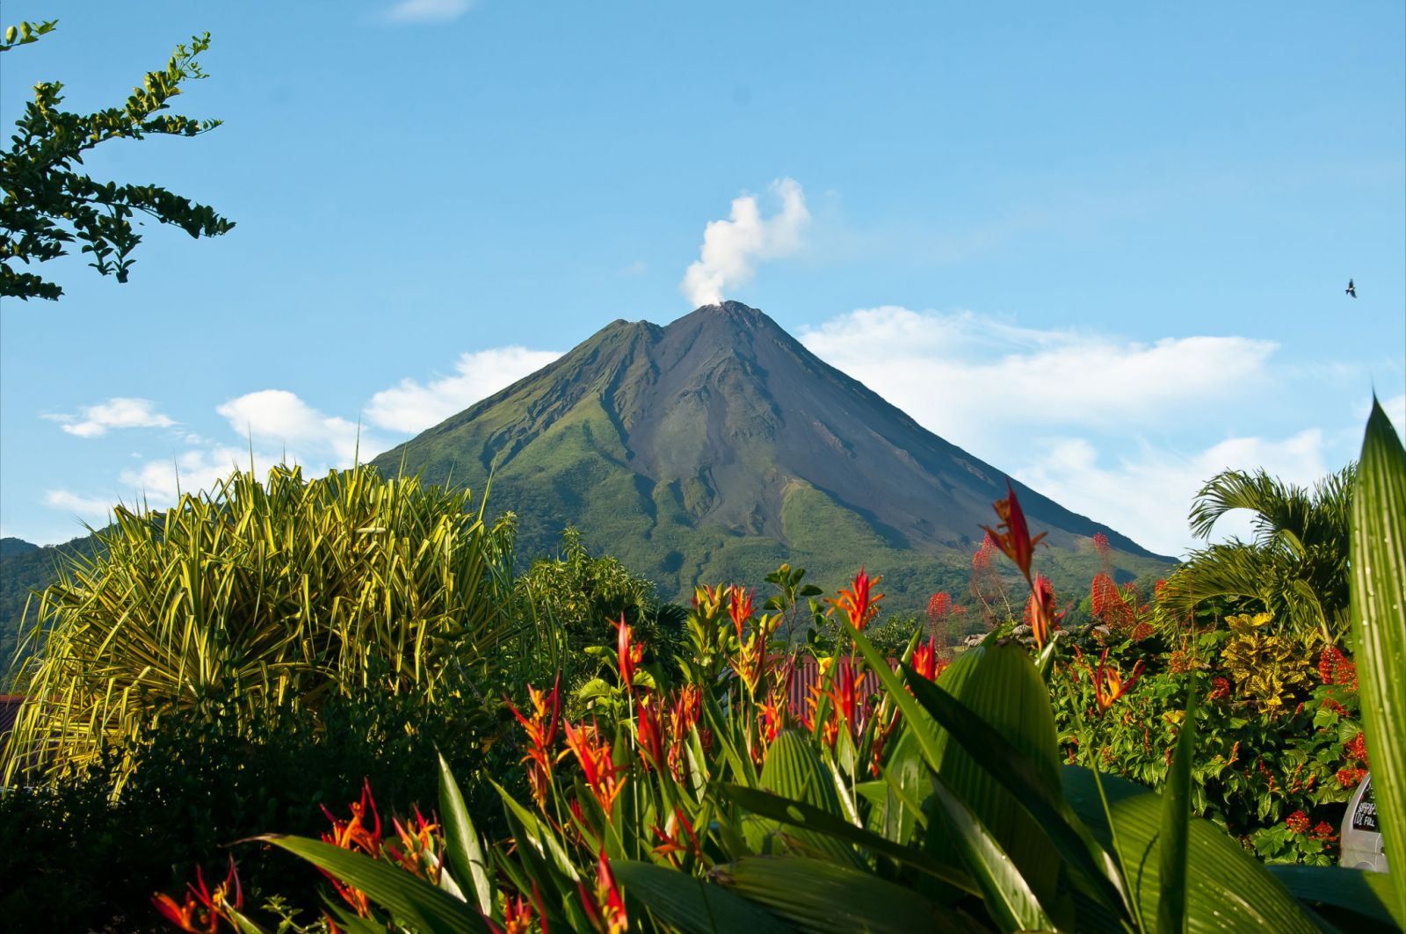



**Rio Celeste Hike**

Located at the Tenorio Volcano, this river is unique in the country. We will take a hike to ¨Los Teñideros¨ where the river takes on a different chemical reaction and it changes color. Include transportation, guide, park tickets and lunch.

Departure Time: 7:00 am - Duration 8 Hrs

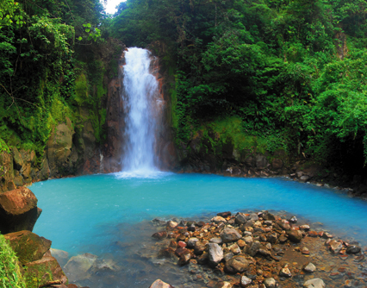

**Cerro Chato Hike**

For people wishing a long hike and with good physical condition for go uphill. This option will take you all the way up to the top of Cerro Chato. From there you will have great views of the Arenal Volcano and San Carlos plains. Include transportation, guide, box lunch and park ticket.

Departure Time: 7:45 am - Duration 7 Hrs

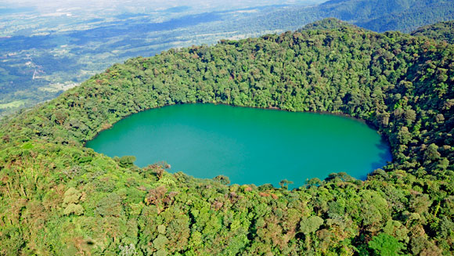

**Hanging Bridges**

Trail of 3.1 kilometers you will go through very impressive bridges, some of them suspended over the forest, from these bridges you will have a great views of the canopy of the rain forest. Include transportation, guide and park tickets.

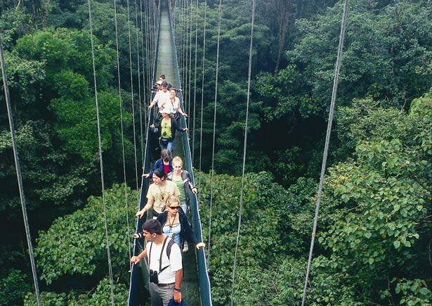Departure times: 7:45 am & 1:00 pm - Duration 3 Hrs

**Nigth Walk**

Trail of 3,1 kilometers you will go through very impressive bridges, some of them suspended over the forest, from these bridges you will have a great views of the canopy of the rain forest. Include transportation, guide and park tickets.

Departure times: 7:45 am & 1:00 pm - Duration 3 Hrs

**Bird Watching**

864 are the species of birds that can be seen all over the country and more than 340 can be found around the Arenal Volcano Area. That's why this is for bird watching lovers. Include transportation, guide and snacks.

Departure Times: 5:30 am - Duration 4 Hrs

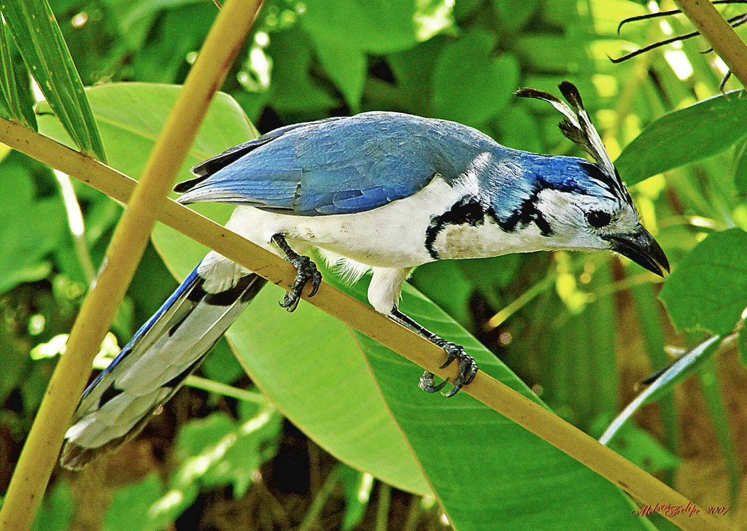

**Unique Caño Negro**

Enjoy the unsurpassed natural beauty of Caño Negro in a peaceful covered boat. Observe waterfowl and a variety of Flora and Fauna. For Nature Lovers. Include transportation, guide and lunch.

Departure Time: 7:00 am - Duration 8 Hrs

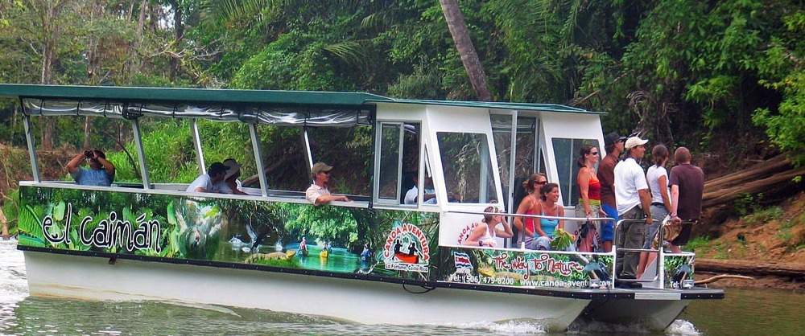

**Safari Float by Raft**

Excellent opportunity to observe local flora and fauna in the calm waters of Peñas Blancas river. Include transportation and guide.

Departure Times: 7:00 am & 1:05 pm - Duration 4 Hrs

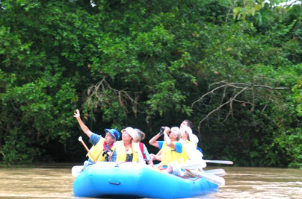

**Kayak on the Arenal Lake**

Discover incredible sceneries and views of the lake, its coast, forest and of course the majestic Arenal Volcano. Include transportation, guide and fruits.

Departure times: 8:05 am & 1:40 pm - Duration 4 Hrs

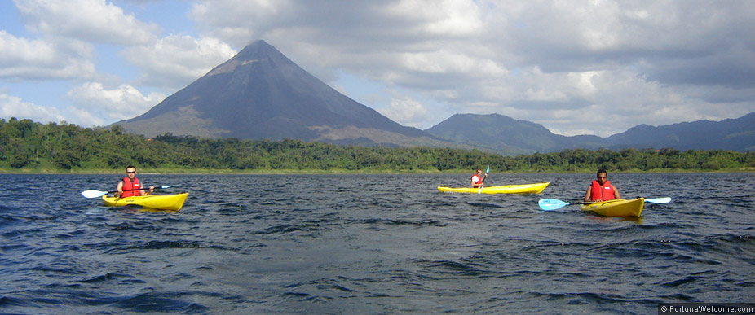

**Cultour Casona Rio Fortuna**

Share our culture, tradition and style of daily life in Costa Rica on a unique tour that combines the beauty of nature and encounters with the local population. Include transportation, guide and lunch.

Departure Times: 8:00 am, 11:30 am & 2:30 pm - Duration 5 Hrs

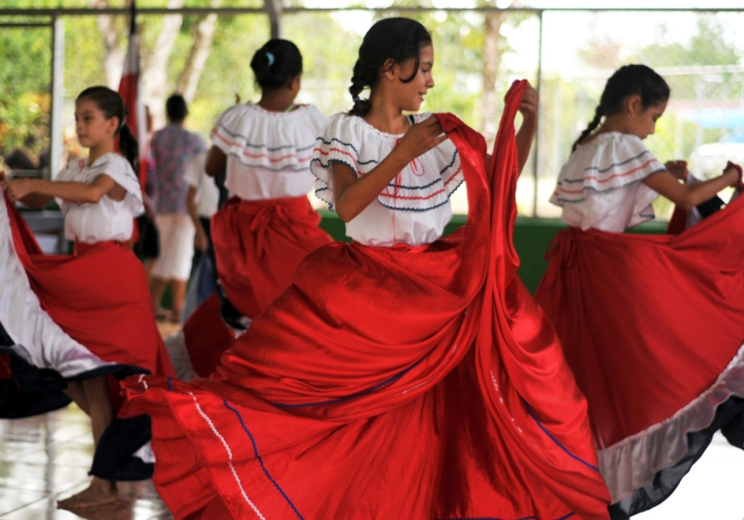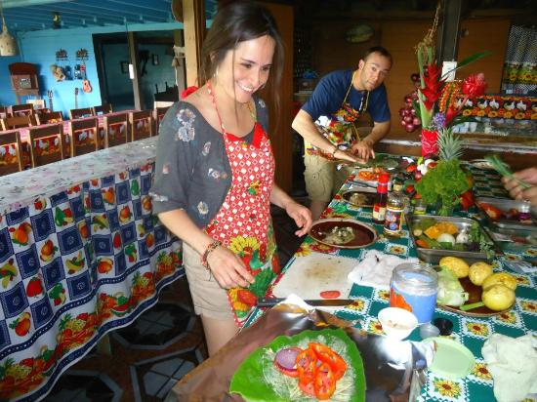



**COMBINATION TOURS**

**La Fortuna One Day**

First we will visit the Hanging Bridges, around 11:30 am will stop at "La Fortuna Waterfall", 1:30 pm Typical lunch, later the Volcano Hike in the National Park and our last stop will be at the hot springs, where will also have dinner.

Departure time: 7:45 am - Full Day Activity

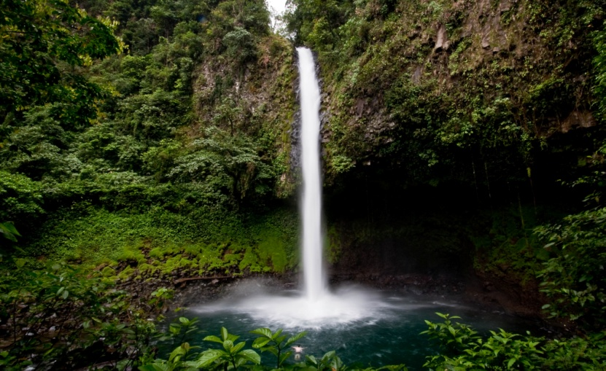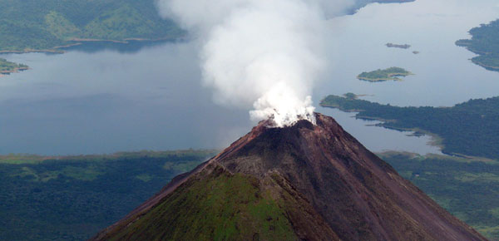

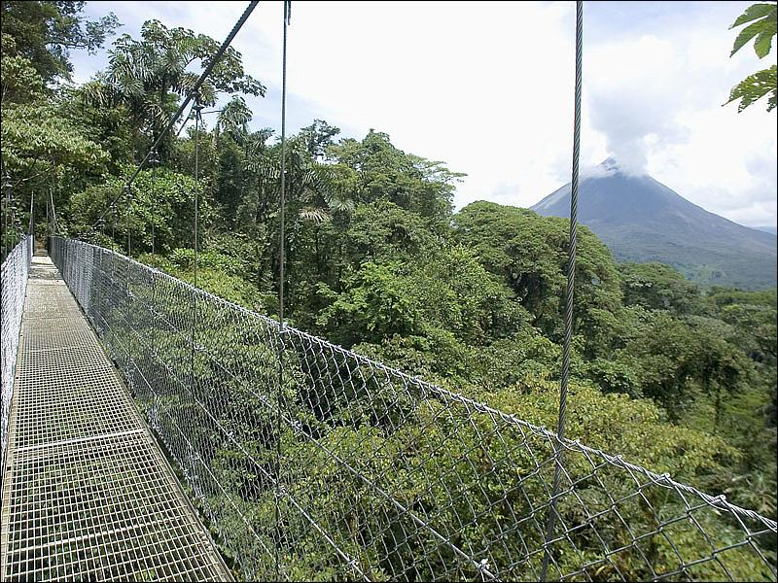



**Volcano Hike, hot springs and one meal**

During the tour you can see a variety of flora and fauna characteristic of the area, while walking along the lava paths of 1992, then relax in the hot springs of your choice with a meal included.

Departure times: 7:45 am & 3:20 pm - Duration 6 hrs

